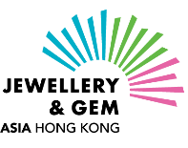 | Free Publicity Opportunities  Jewellery & Gem ASIA Hong Kong  (16 – 19 June 2022)

Dear Exhibitor,
各位參展商：
Thank you for your participation in the 2022 edition of Jewellery & Gem ASIA Hong Kong (JGA)!
感謝 貴公司參與六月香港珠寶首飾展覽會 (簡稱 JGA)。
To capture buyers’ interests in your company and products, please submit high-resolution images and information of your latest, hottest and most exceptional products as well as company logo and introduction for inclusion in our marketing and publicity materials. The more detailed and appealing your information, the higher the chance it will be selected. Your generous offers will be promoted in advance and onsite, bringing great exposure and traffic to your booth!
現誠邀 貴公司提供高解像素的最新、最熱賣暢銷、最獨特的產品照片、產品簡介、公司商標及公司簡介，以及為珠寶愛好者所設的獨家優惠，藉以吸引買家。貴司若能填寫越為詳盡的產品資料，被挑選的機會越高。我們會於展覽會前及期間為 貴司宣傳推廣，藉此帶動展位人流!
The form includes six sections. Here is the overview of the form: 表格包括六個部分：
1. Special Deals (for onsite coupons) and Exclusive Offers (for our Partners)
特別禮遇 (現場派發之禮劵) 及獨家禮遇 (為大會合作夥伴而設)
2. Special Product Offers (for onsite Guide Map) 限時獨家優惠 (現場派發之展會指南)
3. Lucky Draw Prize 幸運大抽獎
4. Free Publicity 免費宣傳
5. Additional Product Exposure 附加產品推廣機會
6. Company Social Media Account 公司社交媒體官方帳號

Submission deadline: 20 May 2022 (Friday)
截止日期： 2022年5月20日 （星期五）

Please complete this form and attach the product photo(s) and company logo, and send those to
Ms Alvia Kwong at Alvia.Kwong@informa.com. 請填妥下列表格，附上產品照片及公司商標，並電郵至 Alvia.Kwong@informa.com 與珠寶展覽市場及傳訊部的鄺穎恩小姐聯絡。

* Important notes重要提示:

Please take note of the required image file formats請注意以下檔案規格：

Company Logo Specification公司商標規格  Format 格式:  AI (highly preferred建議格式)- outlined all text 所有文字轉換成外框曲線 (將文字變成圖形線條)  PSD- remove background褪去背景, resolution解像度 300dpi  Mode色彩模式: CMYK  - Only high-resolution logos are accepted 只接受高解素公司商標  - WordArt and product images are not accepted 不接受藝術字(WordArt) 和產品圖片 | Product image Specification產品照片規格  Size尺寸: 200 x 200 mm (reference size参考尺寸)  Format格式: Photoshop TIFF/JPG/PSD – flatten layers平面化所有圖層 (將所有可見圖層合併至背景圖層)  Resolution解像度: 300dpi  File size圖片檔大小: 2MB+  Mode色彩模式: CMYK  - White background or Die-cut photo with background removal 照片背景：白色或透明 (褪去背景)  - Catalogues are not accepted 不接受產品目錄  *Please state product name(s) clearly on the file name for identification 請在檔案名稱上清楚註明產品名稱，以茲識別

 | SECTION 1: SPECIAL DEALS 第一部份：獨家優惠
1. | Do you have any special offers for JGA22 visitors? 您有沒有為六月展買家而設的獨家優惠？  Examples例如:  - 20% off for special pieces 指定商品可享８折優惠  - 30% off on all products 所有產品可享７折優惠  - 20% off on the second item 第二件商品可享８折優惠  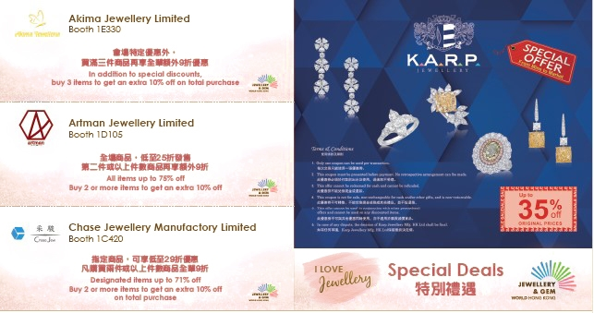  Sample Coupons from JGW21 for reference only  圖片來自2021年九月展，只供參考
 | ☐Yes 有  Please list your most attractive sales promotions to JGA buyers 請列出貴司為六月展買家的優惠詳情。Examples例如:  - 20% off for special pieces 指定商品可享8折  - 30% off on all products 所有產品可享7折優惠  - 20% off on the second item 第二件商品可享8折優惠  Click or tap here to enter text. | ☐No 沒有
Please attach company logo file together with this form
遞交此表格時請附上公司商標檔案

Format 格式:
AI (highly preferred建議格式)- outlined all text 所有文字轉換成外框曲線 (將文字變成圖形線條)
PSD- remove background褪去背景, resolution解像度 300dpi
Mode色彩模式: CMYK
- Only high-resolution logos are accepted 只接受高解素公司商標
- WordArt and product images are not accepted 不接受藝術字(WordArt) 和產品圖片

SECTION 2: SPECIAL PRODUCT OFFERS第二部份：限時獨家優惠
1. | Do you have any exclusive offers to customers of our partners? We are working with various partners to invite their high-income customers to visit JGA. Your exclusive offer to them will boost traffic to your booth! 您有沒有為大會合作夥伴的客戶提供獨家優惠? 我們正與不同的合作夥伴進行商討，邀請他們的高收入客戶群蒞臨JGW。您給予他們的獨家優惠，將有助增加貴司展位的人流!  Examples例如:  - Cash coupon to redeem at your booth 可於貴司JGA展位使用的現金代用劵  - Special discount exclusive to this group 合作夥伴的客戶獨享的折扣優惠  - Limited pieces at amazing prices 價格實惠的限量產品  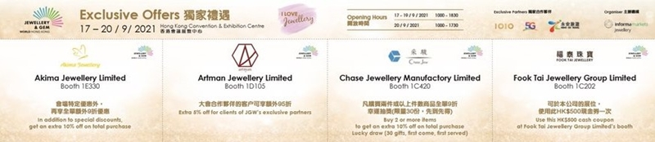  Sample Coupons from JGW21 for reference only  圖片來自2021年九月展，只供參考
 | ☐Yes 有  Please list your exclusive offer to customers of our exclusive partners 請列出為大會合作夥伴客戶而設的優惠詳情。Examples例如:  - Cash coupon to redeem at your booth 可於貴司JGA展位使用的現金代用劵  - Special discount exclusive to this group 合作夥伴的客戶獨享的折扣優惠  - Limited pieces at amazing prices 價格實惠的限量產品  Click or tap here to enter text. |  | ☐No 沒有
Please attach company logo file together with this form
遞交此表格時請附上公司商標檔案

Format 格式:
AI (highly preferred建議格式)- outlined all text 所有文字轉換成外框曲線 (將文字變成圖形線條)
PSD- remove background褪去背景, resolution解像度 300dpi
Mode色彩模式: CMYK
- Only high-resolution logos are accepted 只接受高解素公司商標
- WordArt and product images are not accepted 不接受藝術字(WordArt) 和產品圖片
2. | Limited-time special offers for all visitors提供予所有參觀人士的限時優惠  Capture individual buyers' attention by offering your most attractive jewellery deals, especially goods at affordable price points. 以最優惠的價格吸引參觀者，尤其是價格相宜的產品，吸引他們的目光! 請提供詳細資料，讓我們為您推廣。  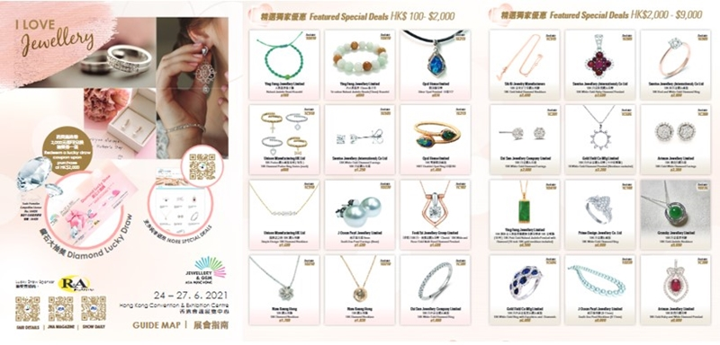  Sample Guide Map from JGA21 for reference only  圖片來自2021年六月展，只供參考
 | Do you have any special deals for the visitors? 您有沒有為買家而設的限時優惠?
 | ☐Yes 有  Please fill in the product details  請填寫產品資料  *Must fill item必須填寫 |  | ☐No 沒有
 | (max. 5 products最多可上載5件產品) | Names of Product in English 產品英文名稱* | Names of Product in Chinese產品中文名稱* | Price of Product (Currency: Hong Kong dollars) 產品價格 (貨幣：港元)
 | Product 1 | Click or tap here to enter text. | Click or tap here to enter text. | Click or tap here to enter text.
 | Product 2 | Click or tap here to enter text. | Click or tap here to enter text. | Click or tap here to enter text.
 | Product 3 | Click or tap here to enter text. | Click or tap here to enter text. | Click or tap here to enter text.
 | Product 4 | Click or tap here to enter text. | Click or tap here to enter text. | Click or tap here to enter text.
 | Product 5 | Click or tap here to enter text. | Click or tap here to enter text. | Click or tap here to enter text.
Please attach product images together with this form
遞交此表格時請附上產品圖片

Please state product name(s) clearly on the file name for identification
請在檔案名稱上清註明產品名稱，以茲識別
Size尺寸: 200 x 200 mm (reference size参考尺寸)
Format格式: Photoshop TIFF/JPG/PSD – flatten layers平面化所有圖層 (將所有可見圖層合併至背景圖層)
Resolution解像度: 300dpi File size圖片檔大小: 2MB+ Mode色彩模式: CMYK
- White background or Die-cut photo with background removal 照片背景：白色或透明 (褪去背景)
- Catalogues are not accepted 不接受產品目錄

 | SECTION 3: LUCKY DRAW PRIZE 第三部份：幸運大抽獎
Visitors who purchase up to a certain amount will be eligible to join our Daily Lucky Draw. Sponsor a lucky draw gift (e.g. your product) and your name or logo will appear on all related promotions as well as the lucky draw* coupon! 參觀人士在展會中購買超過一定金額的貨品，將有資格參加我們的每日幸運大抽獎。贊助幸運大抽獎的禮物（例如您的產品）的參展商，其公司的名字及商標將刊登於所有相關推廣活動及抽獎券中！

*Note: All exhibitors are requested to issue receipts for all purchases onsite to enable visitors to participate in the Lucky Draw. 注意：所有參展商必須為現場售出的商品發出收據，讓參觀人士能夠參加幸運大抽獎。

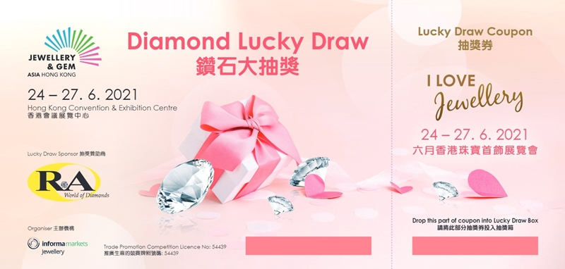
Sample Coupon from JGA21 for reference only
圖片來自2021年六月展，只供參考
 | ☐Yes! We'd like to sponsor a lucky draw prize! 是的! 我們想贊助幸運大抽獎的禮物!  Details of lucky draw prize we would like to offer 我們贊助的禮物詳細資料:  Click or tap here to enter text. | ☐No, not for this time. 這次不用了，謝謝。

 | SECTION 4: FREE PUBLICITY 第四部份：免費宣傳
1. | Would you like to share us your company background/history? (not exceeding 150 words) 會跟我們分享貴司背景簡介嗎? (不超過150字)： | Click or tap here to enter text.
2. | Company Overview/ History (not exceeding 150 words) 公司簡介/歷史 (不超過150字) | Click or tap here to enter text.
3. | Would you like to share us some more product details? (products that ARE NOT MENTIONED in section 2) 可否分享更多產品資料? (只適用於未在第二部份填寫過的首飾系列)
 | ☐Yes 可以  - Product Collection/ Name(s) 產品系列/名稱  Click or tap here to enter text.  - Product Category (e.g. Diamonds, coloured gemstones, pearls, fine jewellery...) 產品類別 (例如：鑽石、彩寶、珍珠、珠寶首飾等)  Click or tap here to enter text.  - Product Description 產品簡介  Click or tap here to enter text. | ☐No 不用了
Your most outstanding or exceptional product for JGA
為六月展而設的獨特產品系列
1. | Are you going to present your most exceptional products/collection at JGA 您會在六月展上展出與別不同的產品系列嗎?
 | ☐Yes 會  What is the most outstanding or exceptional product that you will be presenting at JGA?  Please provide a product description. 您會在展會上展出哪些與別不同的產品? 請提供該些產品的簡介。  - For finished jewellery pieces, share the inspiration behind the design/s, the precious materials used and price/s. 若屬成品首飾類別，請分享設計靈感、所採用之珍貴材料、價錢  For gemstones – including pearls – describe the materials’ quality factors and value. 若屬寶石類別，包括珍珠，請分享寶石原料的質量、等級及價值  Click or tap here to enter text. |  | ☐No 不會
2. | Who are the buyers that you wish to reach at the event? 您期望展會能為您吸引哪一類買家群？ | Click or tap here to enter text.

SECTION 5: ADDITIONAL PRODUCT EXPOSURE
第五部份：附加產品推廣機會
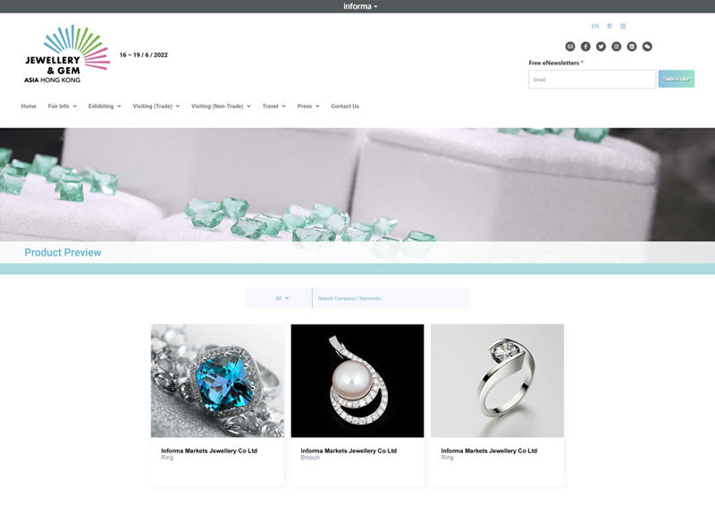
Product Preview on website from JGA21 for reference only
產品預覽來自2021年六月展網頁，只供參考。

(Please fill in only if the products are different from section 2只適用於未在第二部份填寫過的產品系列)

1. | Do you have additional images for product exposure? 您會否提交其他產品圖片讓我們為你推廣宣傳?
☐Yes 會
☐No 不用了
 | (max. 4 products最多可上4件產品) | Name of Additional Product 附加產品的名稱 |  | Product Category of Additional Product (e.g. Diamonds, coloured gemstones, pearls, fine jewellery...) 附加產品的產品類別 (如：鑽石、彩寶、珍珠、珠寶首飾)
 | Additional Product 1  附加產品1 | Click or tap here to enter text. |  | Click or tap here to enter text.
 | Additional Product 2  附加產品2 | Click or tap here to enter text. |  | Click or tap here to enter text.
 | Additional Product 3  附加產品3 | Click or tap here to enter text. |  | Click or tap here to enter text.
 | Additional Product 4  附加產品4 | Click or tap here to enter text. |  | Click or tap here to enter text.
Please attach product images together with this form
遞交此表格時請附上產品圖片

Please state product name(s) clearly on the file name for identification
請在檔案名稱上清註明產品名稱，以茲識別
Size尺寸: 200 x 200 mm (reference size参考尺寸)
Format格式: Photoshop TIFF/JPG/PSD – flatten layers平面化所有圖層 (將所有可見圖層合併至背景圖層)
Resolution解像度: 300dpi File size圖片檔大小: 2MB+ Mode色彩模式: CMYK
- White background or Die-cut photo with background removal 照片背景：白色或透明 (褪去背景)
- Catalogues are not accepted 不接受產品目錄
SECTION 6: COMPANY SOCIAL MEDIA ACCOUNT(S)
第六部份：公司社交媒體官方帳號
Instagram |  |  | Click or tap here to enter text.
Facebook 臉書 |  |  | Click or tap here to enter text.
LinkedIn 領英 |  |  | Click or tap here to enter text.
WeChat 微信 |  |  | Click or tap here to enter text.
Others (please specify) 其他 (請說明)： |  |  | Click or tap here to enter text.
Contact Details 聯絡資料
Company Name公司名稱*: |  |  | Click or tap here to enter text.
Booth Number攤位號碼: |  |  | Click or tap here to enter text.
Country/Region國家/地區: |  |  | Click or tap here to enter text.
Contact Person聯絡人*: |  |  | Click or tap here to enter text.
Email電郵*: |  |  | Click or tap here to enter text.
Contact number電話*: |  |  | Click or tap here to enter text.
*Must fill item必須填寫

Right to publish the information in this form
發佈此表格中的資料的權利

*By filling in the form, you’re giving Informa Markets Jewellery the right to publish the information in this form in the following channels 填寫此表格即表示您授予Informa Markets Jewellery在下列渠道發佈此表格中的資料的權利：
- Event press releases, eNewsletters or promotional flyers展會的新聞稿、電子簡訊或宣傳單張
- Event website and social media channels 展會的網站及社交媒體
- Event Show Daily 展會日報
- JNA and JewelleryNet.com 《JNA 亚洲珠宝》及JewelleryNet
- Your company’s showroom on JewelleryNet.com 貴公司在 JewelleryNet.com 的網上陳列室
Informa Markets Jewellery reserves the right to select what information may be included in its promotion campaigns. Informa Markets Jewellery保留修改及刊登已遞交照片的最終權利。

